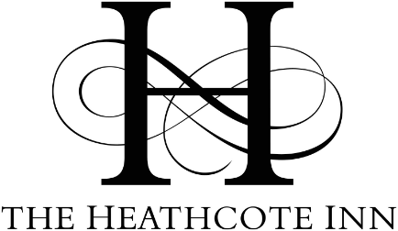
Christmas Day
Adults £55 Children 8-12years £28 Children under 7 £14 (children order 7 can order from the menu if they want)
Starters
Wild mushroom soup, fricassee of mushrooms, finished with mascarpone and toasted sour dough crouton.
Home cured gravlax with chive crème fresh and a cucumber & dill salad
Game terrine with West Country apple & cider chutney, tomato & red onion salad and toasted sour dough bread.
House smoked duck breast, rocket salad, with dementine and coriander dressing.
Asparagus & pea girasol, wilted leaves with fennel & chilli infused butter.
Baked camembert with pickled walnuts and a fig & pear balsamic glaze.

Main Courses
All served with roast potatoes, glazed heritage carrots, honeyed parsnips and Brussel sprouts with pancetta & chestnuts
Roast Norfolk Turkey with festive sausage meat stuffing and chipolatas.
28 day matured Sirloin of Beef with homemade Yorkshire pudding.
Roasted Lamb Rump, with rosemary, red currant and red wine sauce.
Gressingham Duck with Morell cherry & bitter chocolate sauce
Pan fried Hake in a white wine butter & chive sauce with prawns and mussels.
Roasted vegetable tagine, roasted cauliflower, harissa couscous, yoghurt & coriander dressing, pomegranate jewels and homemade flat breads.

Desserts
Ginger, rum and raisin pudding, served with clotted cream, ice cream or crème anglaise.
Lemon shortbread cheesecake with fresh berries, raspberry coulis & Madagascan vanilla ice cream.
Chocolate & Raspberry tear: Belgian chocolate mousse on a sponge base, finished with raspberry coulis & raspberry ripple ice cream.
White chocolate and orange crème brulee with shortbread and Madagascan vanilla ice cream.
Cheese Board: Roquefort, soft goat’s cheese, vintage cheddar and Red Leicester.

Tachbrook Road
Leamington Spa
CV31 3DG
01926 887 000
info@heathcoteinn.co.uk

