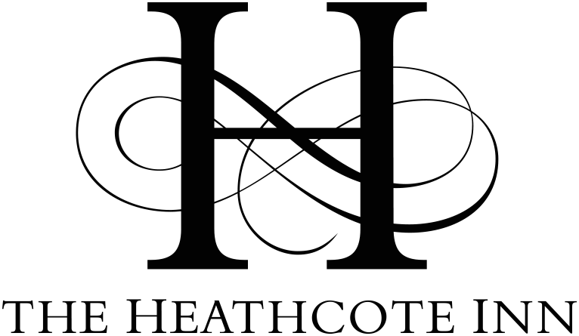

Christmas Fayre
Main course £16.95 Dessert-£4.95
Starters
Homemade spiced cauliflower & saffron soup
Chicken liver parfait with spiced cranberry jam & toasted sour dough bread
Prawn cocktail with bloody Mary sauce & rye bread
Baked camembert, toasted ciabatta & roasted red onion chutney

Main Courses
Roast Norfolk Turkey, pig in blanket, sage & onion stuffing, baby roast potatoes and seasonal vegetables.
Chicken breast in a cream & basil sauce with roasted peppers & courgettes, seasonal vegetables and baby roast potatoes.
Venison steak, with a wild mushroom and Madeira sauce, baby roast potatoes & seasonal vegetables. (Supplement of £3)
Salmon and crayfish fiorelli, with a Mediterranean sauce, rocket, cherry tomatoes & parmesan.
Pumpkin, red onion & cranberry tagine with couscous, yoghurt and mint drizzle & flatbread (vegan friendly)

Desserts
Salted caramel profiteroles, vanilla ice cream and salted caramel sauce.
Belgian chocolate tart, with an amaretto crumb & Madagascan vanilla ice cream.
Sticky Figgy pudding- a light Figgy pudding pudding with a sticky toffee sauce served with crème anglaise.
Raspberry and white chocolate brulée cheesecake with raspberry ripple ice cream.

Tachbrook Road
Leamington Spa
CV31 3DG
01926 887 000
info@heathcoteinn.co.uk

